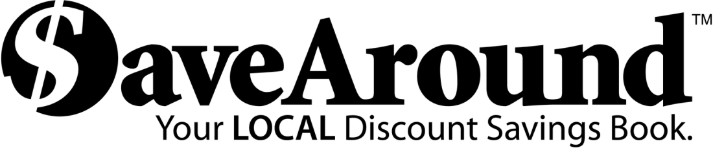

Dear Parents:
Lakewood Elementary is sponsoring the SaveAround sale to raise funds for our school. SaveAround is a coupon book that offers hundreds of buy-one-get-one-free discounts, along with many other great discounts.
You buy one book for just $25. You will find that the book pays for itself after using it just 2 or 3 times. You make your money back and more.

Start Date: September 20, 2016
- A sample coupon book, with attached order form, will be sent home with each student.
- For every 5 books a student sells, he/she will get 1 book FREE!
- This is not meant as a door-to-door sale to strangers. The safety of your student is our first concern. Parents, try to sell to relatives, neighbors and co-workers.

End Date: October 7, 2016
- Return the order form envelope and payment for all orders in the envelope to your child’s teacher, by FRIDAY, October 7.
- Make cheques payable to: Lakewood PAC
- If you didn't sell a book, return the sample book to your child’s teacher by FRIDAY, October 7.
- Any unsold books must be returned or the school will be charged.

Thank you for supporting your school!

