MINI
CHEER
CAMP

WHAT: Great opportunity for an introduction to cheerleading or to improve cheerleading skills. Meet the Belmont Secondary Cheerleaders and enjoy fun games and activities. Camp will be taught by current Belmont Secondary Cheerleaders and supervised by current program coaches.
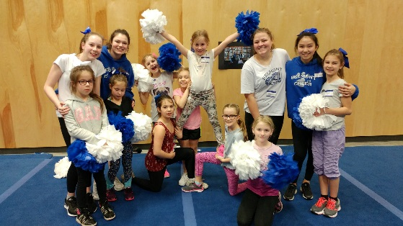
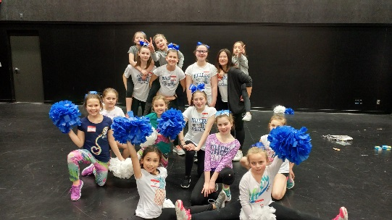
WHEN: Friday October 19, 2018 (Pro-D day)
9 am to 4 pm
WHERE: Belmont Secondary School
(3041 Langford Lake Rd)
WHO: Girls and Boys, age 7 to 13, NO EXPERIENCE NECESSARY!
THEY WILL LEARN: proper cheer motions and techniques, jumps, cheers, some “tumbling” and minor “stunting”. They will also be making cheer crafts, and if weather permits, they’ll help the Belmont Cheer team by cheering at a football game!
WEAR: athletic shorts or leggings, running shoes, t-shirt. Hair must be pulled back and off the shoulders. For safety purposes no jewelry or gum is permitted.
COST: $40 / person
REGISTRATION DEADLINE: Please email Rachael Sandberg (Belmont Cheer team coach / teacher) at rsandberg@sd62.bc.ca before October 12, 2018. SPACE IS LIMITED! MUST PRE-REGISTER. NO DAY-OF DROP OFF IS ALLOWED.

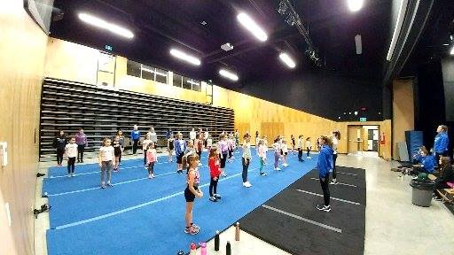
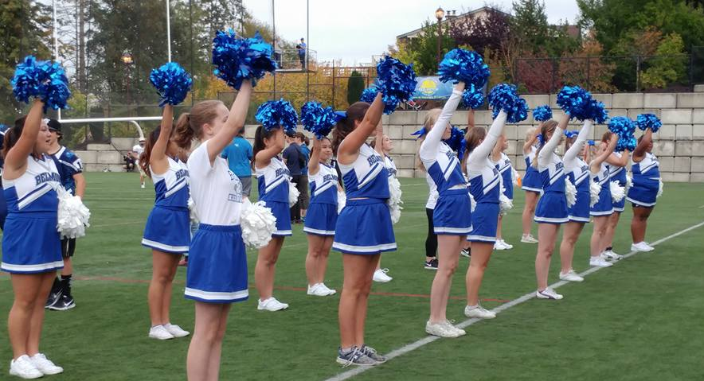

PARENT DROP OFF/PICK UP: The person picking your child up must match the name on the registration form. ID will be required. Your child’s safety is what is most important to us.
SNACKS / LUNCH: EACH CHILD MUST BRING THEIR OWN LUNCH, SNACKS, AND WATER BOTTLE
DIGITAL PICTURES: Pictures will be taken throughout camp and will be uploaded to the Belmont Cheer Team Facebook page, and may be used for future promotions.

